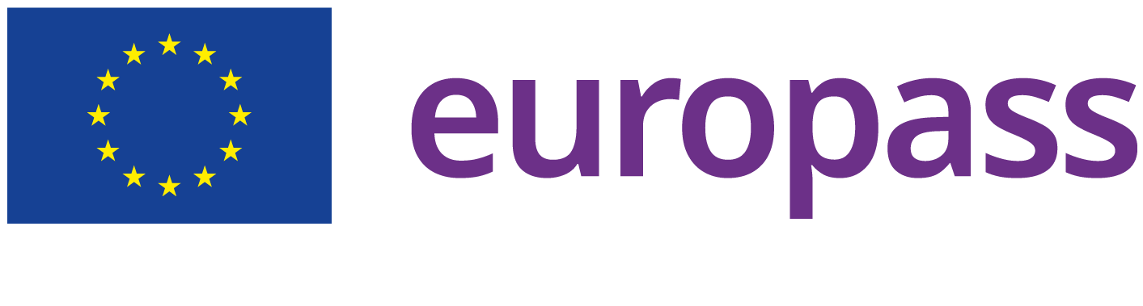

ABOUT ME

SUTHERGELIN HAPPY
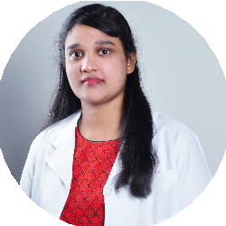
 Home : Bin hamooda tower, Liwara ,Ajman, United Arab Emirates, Ajman, United Arab Emirates
 Email: sh8301@gmail.com  Phone: (+971) 544026908
 Whatsapp Messenger: +971544026908
 LinkedIn: https://www.linkedin.com/in/happyephin-happy-0098a31a3
Gender: Female Date of birth: 21/11/1983 Nationality: Indian

17 yrs of clinical experience in handling all Dental patients . Holding MOH License D51334. I am an enthusiastic, self-motivated, reliable, responsible and hard-working person. I am a mature team worker and adaptable to all challenging situations. I can work well both in a team environment as well as using own initiative. I am a hardworking, honest individual. Patient friendly , Sound clinical knowledge , Good communication skills
, Self-motivated and Organized.

WORK EXPERIENCE
[ 01/06/2021 – Current ] DENTAL SURGEON

ALZORA MEDICAL CENTRE
City: Ajman
Country: United Arab Emirates
- Examine ,Diagnose and Treat oral diseases.
- Perform all Dental procedures (Extraction, Surgical Extraction, Rotary Root Canal treatment, Restoration, Veneers, Crowns and Bridges, Bleaching, Scaling and Root planning, Gingivectomy, Gingival Curettage, Fancy Ortho, Removable Orthodontic Treatment, Partial denture, Complete Denture).
- Educate patients on preventive dental care and oral health care .Conducting oral screenings to identify diseases and infections. Ordering diagnostic measures, such as x-rays, models, etc.
- Managing and communicating with other staff members to provide care to patients.
- Ensure that work area in maintained safe clean and organized .
[ 10/11/2019 – 15/05/2021 ] GP DENTIST

AHALIA MEDICAL CENTRE
City: Ajman
Country: United Arab Emirates
- Meeting with patients to discuss and treat dental concerns, perform regular cleanings and other preventative procedures, and establish a plan for better dental hygiene.
- Performing dental procedures, such as extractions, root canals, and filling cavities.
- Correcting bite issues and overcrowding.
- Protecting teeth by using sealants or whiteners.
- Prescribing medications for dental problems, such as pain medications or antibiotics.
- Administering sedatives or anesthesia prior to treatments.
- Ordering diagnostic measures, such as x-rays, models, using tools, such as drills, probes, brushes, or mirrors to examine and treat teeth and mouth.

- Keeping records relating to the oral health of patients and the treatments given to them.
- Managing and communicating with other staff members to provide care to patients.
[ 01/03/2018 – 31/10/2019 ] GENERAL DENTIST

SHIFA ALJAZEERA MEDICAL CENTRE
City: Ajman
Country: United Arab Emirates
- Examine patients and maintaining medical records.
- Prepare patients for treatment (e.g., by applying oral sedation or anesthesia)
- Examination of teeth, gums and other parts of the mouth, along with X-rays to diagnose dental problems.
- Dental prophylaxis
- Identify tooth decay and replace cavities with fillings.
- Design and fit dental prosthetics, such as bridges, crowns, and dentures
- Apply teeth-whitening treatments.
- Conduct tooth extractions and root canal procedures.
- Perform surgeries on diseased tissues and bones.
- Prescribe medication as needed.
- Educate patients on proper brushing techniques, flossing and fluoride use.
- Promote good oral health and preventive dental care (e.g., by scheduling regular check-ups)
- Monitor and maintain Proper Infection control.
[ 01/07/2013 – 31/08/2017 ] DENTAL PRACTITIONER

ALKARAMA STAR DENTAL CLINIC
City: Muscat
Country: Oman
- Interpreting X rays and Monitoring the growth and development of teeth and jaws .
- Observe bonding, restorations, tooth extraction, periodontal surgery, dentures, root canal, and crown placement.
- Perform dental surgical procedures including extraction of teeth or restoration of decay teeth.
- Fixing or removing damaged teeth Filling cavities.
- Performing exams and evaluating x-rays to determine a patient’s health.
- Developing treatment plans to deal with any dental health issues.
- Administering or prescribing medications to decrease pain and improve patient health.
- Interacting with patients and instruct them on proper oral care.
- Instruct patients about best practices in oral health and recommend proper prophylaxis measures

EDUCATION AND
TRAINING
[ 01/11/2001 – 21/02/2006 ] BACHELOR OF DENTAL SURGEON . BDS

DR MGR MEDICAL UNIVERSITY
Address: Kulasekharam, Tamil Nadu, Nagercoil, India

LANGUAGE SKILLS

Mother tongue(s): Tamil

DIGITAL SKILLS
Other language(s):

English
LISTENING C2 READING C2 WRITING C2
SPOKEN PRODUCTION C2 SPOKEN INTERACTION C2

Malayalam
LISTENING C2 READING A2 WRITING C2
SPOKEN PRODUCTION C2 SPOKEN INTERACTION C2

Arabic
LISTENING B1 READING A1 WRITING A1
SPOKEN PRODUCTION B1 SPOKEN INTERACTION B1

Hindi
LISTENING C2 READING B1 WRITING A1
SPOKEN PRODUCTION C2 SPOKEN INTERACTION C2

Microsoft Word | Microsoft Excel | Microsoft Powerpoint | Google Drive | Zoom | LinkedIn | Facebook | Skype | Organizational and planning skills | Good listener and communicator | Social Media

DRIVING LICENCE

Motorbikes: A2

Cars: B

PROJECTS
[ 01/04/2020 – 31/05/2020 ] VOLUNTER DOCTOR IN COVID CARE
- Maintaining the medical records of covid patients
- Administering medications
- Monitoring their vital signs on daily basis
- Uploading feedback regarding patient history and the availability of rooms in system
- checking the stocks and updating in systems

